CS5590 – Big Data Analytics

Lab3 Report

Submitted by Giresh

Created an android application with buttons to represent the CRUD procedures of Hbase data transfer.

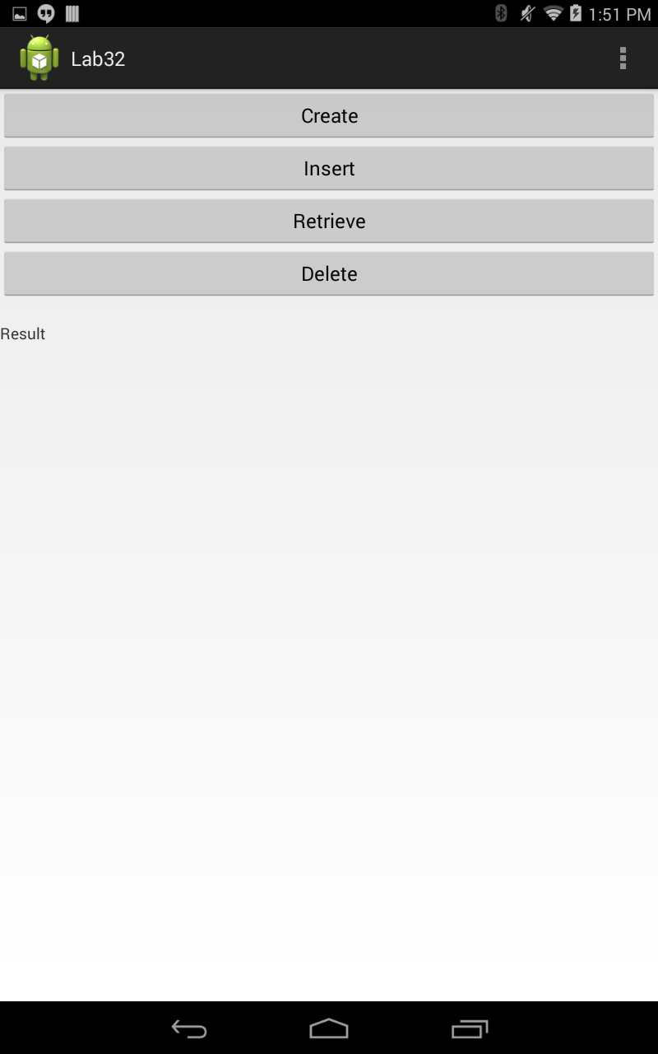

Using android async task I called the service links in background and on post execute the ui changes were made.

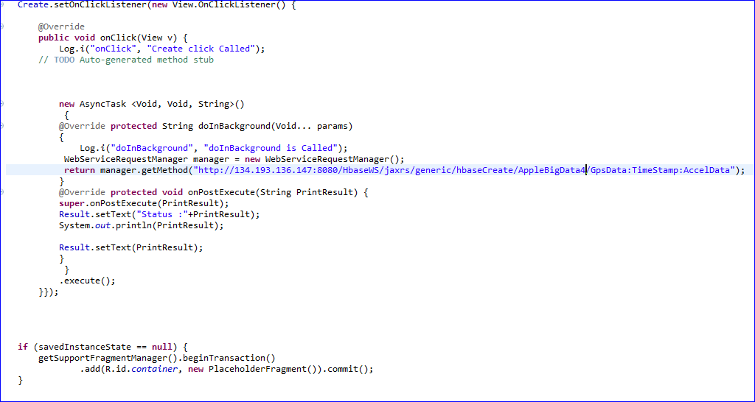

The text file is uploaded to the remote Cloudera, using Winscp

The table is successfully created over hbase

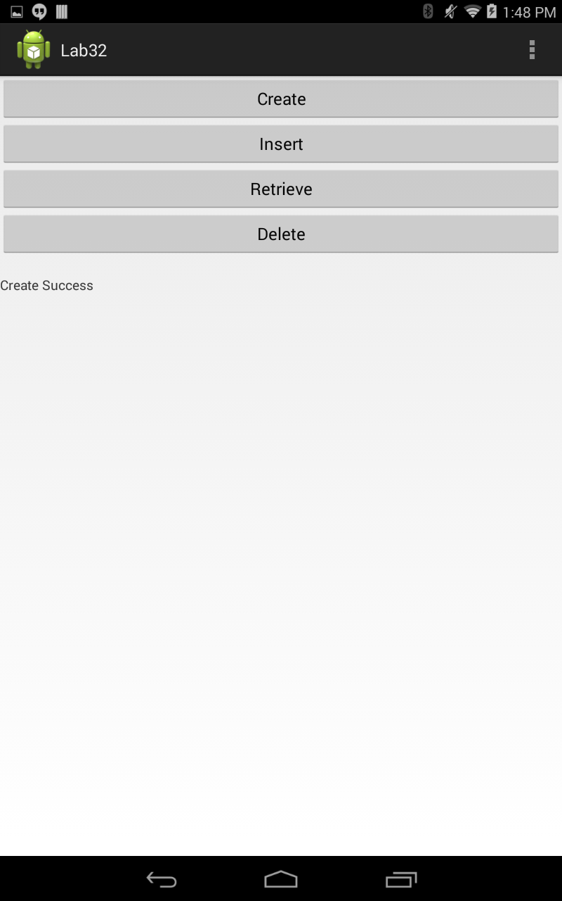

On button click to the Insert, the table is created in Hbase and can be viewed from the android app which returns the Jason text ie insert success

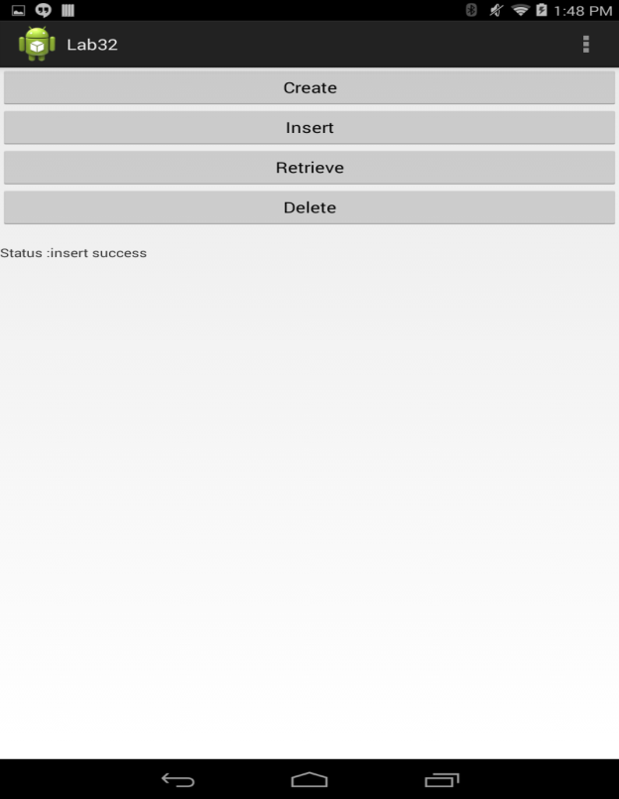

On Retrieve event the application calls the remote retrieve function by assync task and on the post execute it updates the UI part of the file.

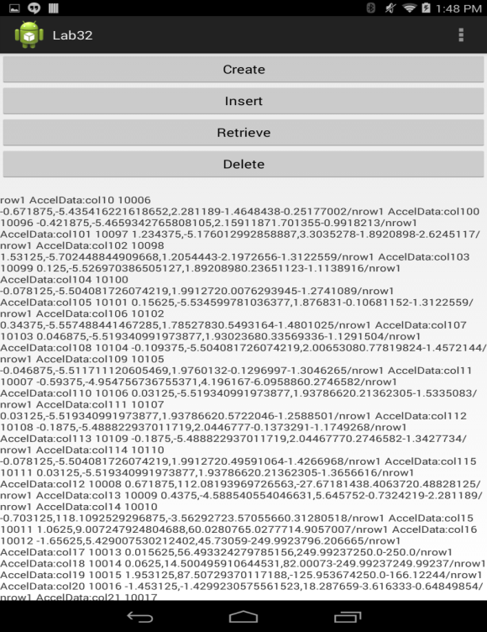

On the delete event the table is deleted from the hbase

